
National University of Computer & Emerging Sciences, Karachi
Spring-2021 CS-Department
Final Exam
11th of June 2021, 9:00 am – 12:00 pm
Course Code: CS301 | Course Name: Theory of Automata
Instructor Name: Mr. Shahzad, Ms. Shaharbano, Ms. Bakhtawar, Mr. Musawar
Student Roll No:

Instructions:
- Return the question paper.
- Attempting of the question in the given order is highly encouraged.
- Read each question completely before answering it. There are 6 questions on 3 pages.
- In case of any ambiguity, you may make assumption. But your assumption should not contradict any statement in the question paper.

Time: 180 minutes. Max Marks: 160 points

Question 1: Regular expression & Properties (5+5) Points
a) Give the equivalent REs for the following regular expressions other than the given one.
1. (b + bb)* a (b + bb)*

Solution:

b*ab*
2. (bb)(bb)* a*(bb) + (bb)⁺ a* (bb)*(bb)

(bb)⁺a*(bb)*

b) Let L₄ = L₁ U L₂ . If L₁ is regular and L₂ is not regular, then L₄ is regular. Discuss with an example.

Solution:
a^{n} b^{n} and (a+b)* unite to form (a+b)* which is regular language

Question 2: Finite Automata (10+10+10) Points

a) Find out the union and intersection of the following FAs.
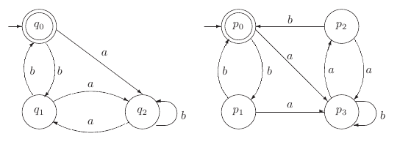
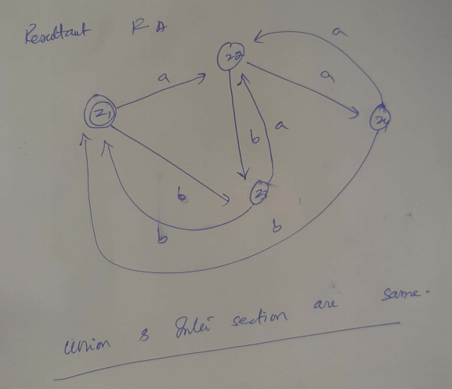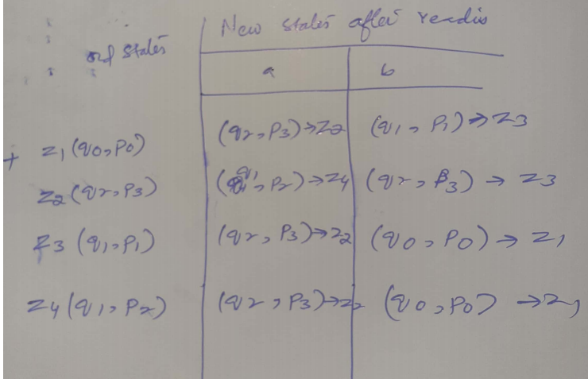

b) Convert the following NFA to equivalent DFA.
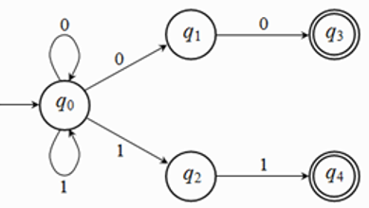
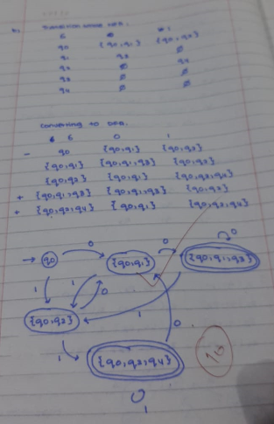
c) Provide the Deterministic Finite Automata and transition table also mark the initial and final states for the following real world scenario:



Kitchen
Bed Room
L2
L3




L1
P2
P1

We have a house, with one door, 2 push buttons and 3 lights. At the default state the lights are all turned off. In your case consider buttons as p1 and p2, lights as l0 (no lights on), l1, l2 and l3 and you must consider l1 as the entrance light.
- When you enter the house, you can press one of the 2 push buttons you have, p1 or p2. When you press any of those buttons, the l1 light turns on.
- Now you have entered the house and you want to move to the house rooms. (Kitchen or bedroom).
- If you press the button p1, l1 turns off and l2 turns on. Instead if you press the button p2, l1 turns off and l3 turns on.
- Pressing another time any of the 2 buttons, p1 or p2, the light that is currently on will turn off, and we’ll get back at the initial state of the system.
- In your case you may consider l0, l1, l2 and l3 as states, p1 and p2 as the alphabet.

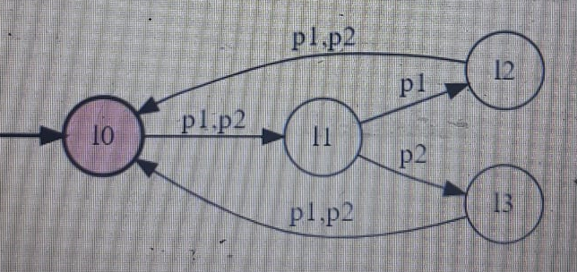

Question 3: CFG (5+5+5+5+5+5) Points
Construct a CFG which generates the following languages:
- L4 = { 0^{i}1^{j}2^{k}| i,j>=0,k>=2}
- L1 ={ 0^{i}1^{j}2^{k}|k <=i }
- L2 ={ 0^{i}1^{j}2^{k}|k <=j }

- Find L3 = L1∪L2

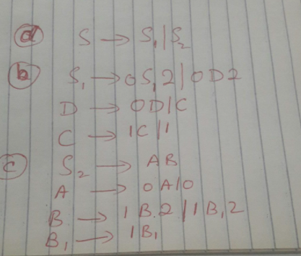
- Construct left most derivation tree for string 001122 for language L1 and L2.
- 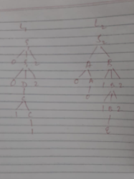
- Check whether the grammar L3 is ambiguous, take expression W=001122.

Question 4: CNF (10+10) Points
Consider the following CFG for non-empty language:
S → a|aAb|abSb
A → bS| aAAb| Cab | ε
B → ab |AS | ε
D → bS| Cab| ε

- Simplify showing each steps clearly.
S → a|aAb|abSb
A → bS| aAAb| Cab | ε
B → ab |AS | ε
D → bS| Cab| ε
B, C and D are useless productions
S → a|aAb|abSb
A → bS| aAAb| ε

Remove A→ null

S → a|aAb|abSb | ab
A → bS| aAAb| aAb | ab

Rest Can be converted into CNF
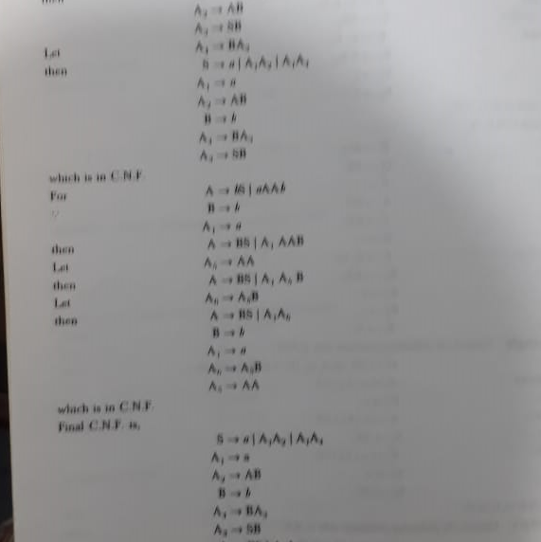

- Convert the above CFG into CNF.

Question 5: P.D.A. (10+10) Points
- Identify language of given CFG, construct a P.D.A. and trace the input string ------ using stack :
S→ 0S11| 0S111 |^
Trace the input string "0011111" using stack. Is the string accepted by the grammar?

- Construct a PDA for language L ={ a^{n}b^{m}c^{k}d^{l}|n+m = 2(k+l) ≥0}. Trace the input string, which belong to language (length of string should be at least 6) using stack.

I considered the possible variations also

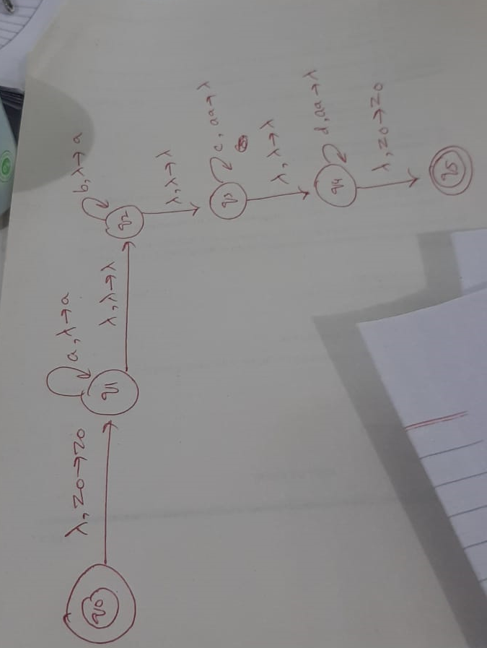

Question 6: Turing Machine. (10+10+5) Points
a) Design Turing machine for language:
- L = {0^{n}1^{m}| 2n<=m<=3m}
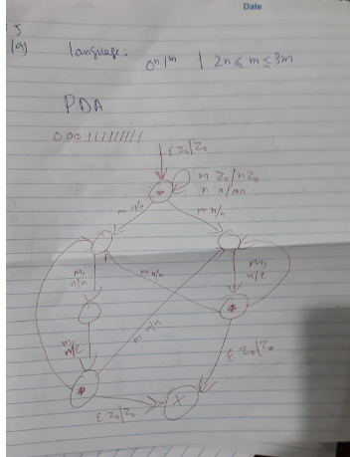
- L = { abb (a + b)*}
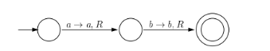
- Draw Chomsky Hierarchy and discuss.
- 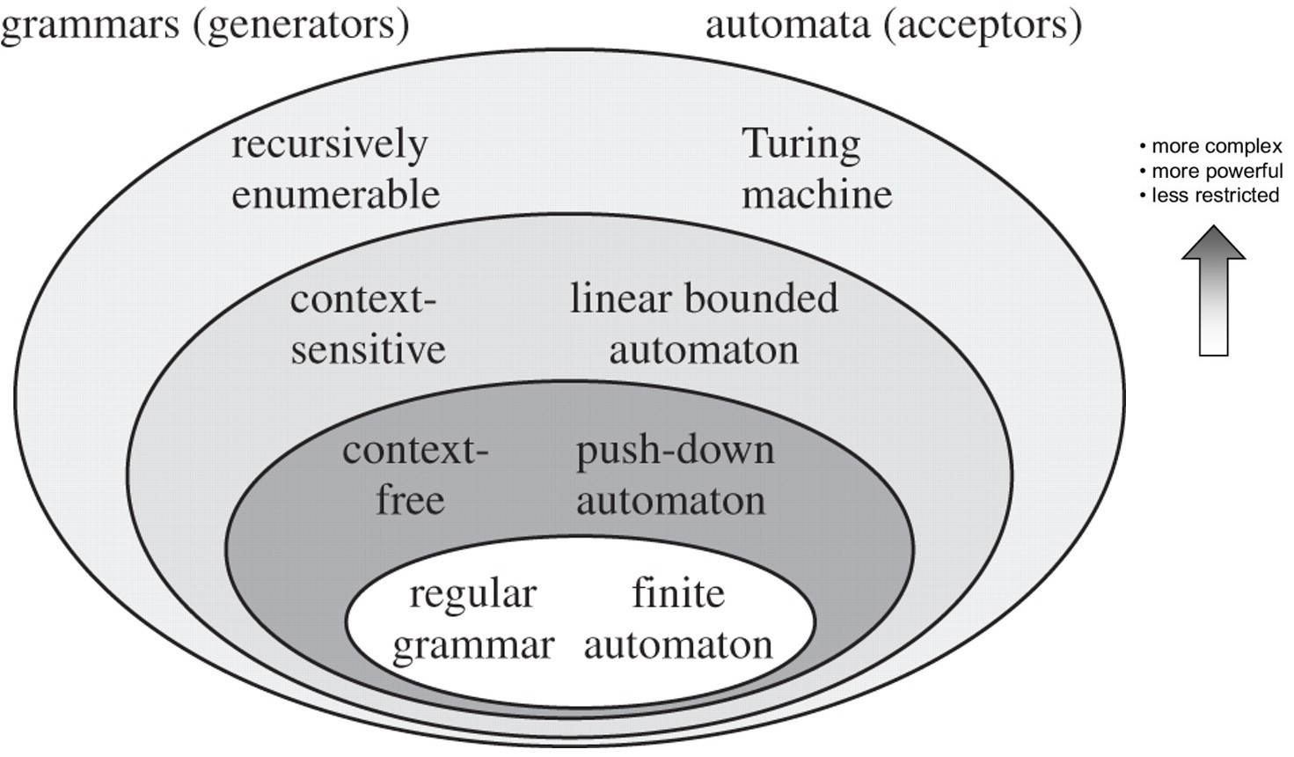
b) Give Pseudocode and its corresponding TM for the following functions:
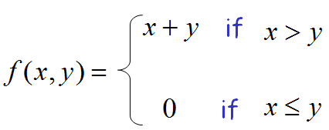
(15+10) Points

- A = {0^{n} | n is a power of 2}

M2 = “On input string w:
1. Sweep left to right across the tape, crossing off every other 0.
2. If in stage 1 the tape contained a single 0, accept.
3. If in stage 1 the contained more than a single 0 and the number of 0s was odd, reject.
4.Return the head to the left-hand end of the tape.
5.Go to stage 1.”
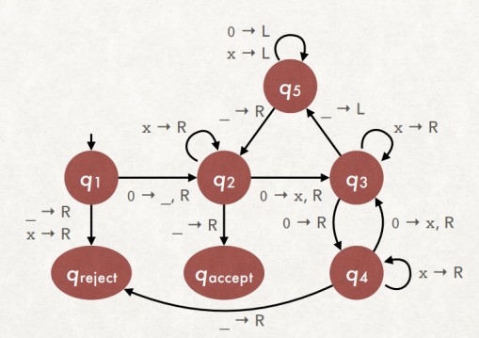
Source: https://www3.nd.edu/~dchiang/teaching/theory/2018/www/tm-slides.pdf

BEST OF LUCK!

